1. **ABOUT US**

* BUDANIA IAS
* AB SIR
* AB PLUS TV
* AB GURUKUL
* SIKAR TEST WALA

1. **TEAM**
2. **COURSES P**
3. **CENTRES**
4. **GALLERY**
5. **REMOVE FRANCGHISEE , RESOURCES**
6. **BUY ONLINE**
7. **DEMO VIDEOS**
8. **STUDENT ZONE**

**10.CONTACT US**

**AMIT BUDANIA SIR**

**POPULARLY KNOWN AS – AB SIR**

6 YEARS + TEACHING EXPERIENCE

**EXPERT ANALYST** OF POLITICAL SCIENCE, ECONOMY , INTERNATIONAL RELATIONS AND SOCIAL ISSUE and justice , current affairs ( UPSC and PCS level)

**Achievement:-**

**PROUD OF NATION 2019** awarded by Defense Minister **Mr. Rajnath Singh** at Delhi for contribution in academics of defense related families. - **Best youngest UPSC trainer** awardee **INDIA BUSSINESS AWARD 2019,** **BANGALORE - YOUTH ICON OF EDUCATION SECTOR** – **Asia education summit 2019, Mumbai** - More than **195 aspirants** are elected as government servant under my guidance.

**Ab plus tv**

**Ab plus tv** is a digital unit of Budania IAS group. It was founded on September 5, 2019 with the objective of free education and spreading awareness across society on social and political issues. Our mentor Mr Amit budania has a vision to spread quality education across Rajasthan. Proper guidance always leads to better outcome. Along with economic activities budania IAS wants to return society as much as we can , with this humble dream we established our digital unit Ab plus tv. We provide free educational videos through Face book and you tube . In order to develop society we also telecast social political awareness programmes on our channel.

**AB GURUKUL**

**AB GURUKUL** is a residential academy for civil services aspirants- for both boys and girls . it is the brain child of **BUDANIA IAS** It is unique in itself only and first of all its kind of an initiative in Rajasthan for those who wish to pursue their dreams leaving their homes many km away . It is another home for such aspirants.

**The AB GURUKUL is having the following facilities :-**

**•** **Comfortable residence**

**• Conductive environment for aspirant**

**• Personal guidance by mentors**

**• Food like home**

**• Security surveillance**

**• RO water in campus**

**• Separate study portion**

**• Facility for visitors, parents**

**• Full family pack system**

**Sikar test wala**

**Sikar test Wala** is powered by BUDANIA IAS, a well known brand in education sector of Rajasthan. We believe that classroom learning and self study requires regular evaluation. Study without check is always have the possibility to be diverted from Target. We believe in strengthen your knowledge as per exam. Our test series module is based on exam conducting board patterns. Our experts analysis every paper twice and make sure to cover the questions as per nature of examination. We have collaboration with more than 15+ mentors and leading coachings for all courses of test series with timely schedule and expert view. We provide a balanced approach.

Your dreams are our passion With the experience of Budania IAS and AB Plus TV venture , we assure you for quality material and management.

Courses :-

**IAS**

**RAS**

**RJS**

**BUY ONLINE**

**CENTRES :-**

**GANGANAGAR CENTER**

**Center Manager:**Miss Ritu Ritesh  
**Address: 60 E- BLOCK , NEAR GANDHI PARK, ABOVE KRISHNA JWELLERS , SHRIGANGANAGAR   
Phone-** 7023150481

**RATANGARH CENTER**

**Center Manager:**MR. JAI KRISHAN BHOJAK  
**Address:**OPP. TEERAPANTH BHAWAN,RATANGARH  
**Phone-** 9660466872

**RAWATSAR CENTER**

**Center Manager:**MR NARESH SAI  
**Address:**WARD NO 13 M.D. SCHOOL , RAWATSAR  
**Phone-** 9799523158

**HANUMANGARH CENTER**

**Center Manager:**MR SURENDER SAI  
**Address:**Behind Beniwal hospital, Near Rajiv chawk , Hanumangarh Junction   
**Phone-** 9529900000

**SIRSA CENTER**

**Center Manager: NEERAJ SIR**  
**Address:**HISAR ROAD , NEAR NEW BUS STAND, SIRSA  
**Phone-** 9466334421

**STUDENT ZONE :-**

* UPSC
* RPSC
* NCERT BOOKLIST
* REFERENCE BOOKS
* TODAY UPDATE

**TEAM :-**

* **DIRECTOR**
* **ADMINISTRATION**
* **FACULTY**

**DIRECTOR :- ……..**

**MANAGING DIRECTOR- MR AMIT BUDANIA PIC-1**

**I believe that efforts and skills can make every person achieve targets of life.**

**To create and maintain academic excellence, we engage ourselves with cutting-edge research and constantly interact with the industry. Through these processes, we are able to foresee the complex problems that our society may face tomorrow and provide solutions to these problems ahead of time.**

**Furthermore, we realized that if we do not learn lessons from our traditional wisdom and blend it with the modern trends, we would turn short-sighted. Therefore, we have created the Indian Business Museum, which aims to inform the members of our community about our strength and weakness.**

**Additionally, we strongly believe that an education without human touch could be detrimental for our progress. Consequently, in addition to topical issues in education, we offer lessons from Humanities & Liberal Arts to foster the imagination of the members of our community.**

**Amit Budania is Delhi University graduate in Economics post graduate in political science having the skill and commands over many more than 5000 students in few cites engaged with social studies and from last 4-year teaching aspirants of IAS-RAS with experience of more than 13000+ hours classes.**

**ACADEMIC DIRECTOR- MRS MITALI AMIT BUDANIA PIC-2**

**Our mission is to mentor aspirants in a way that they realize their dormant talent and explore their inherent potential. We earnestly believe that there is a great fire in everybody and the only effort required is ‘giving wings’ to that fire and BUDANIA IAS helps it. When students come to us with a desire to achieve something significant in their lives, we make that desire ‘very intense’ and transform their desires and aspirations into achievements”,**

**The guiding philosophy of the institute, throughout, has been the creation of knowledge. The objectives of imparting education, combined with creation, dissemination, and application of knowledge, are being met in an integrated form, to create a synergetic impact.**

**I myself cleared RAS (STATE PCS) twice which helps me to monitor the teaching methods with regular guidance and help me to work out every possible step with aspirants to achieve their goal.**

MEET OUR TEAM

**LAXMI KILANIYA**

(SENIOR MANAGER)  
Ph.:- 8690932020

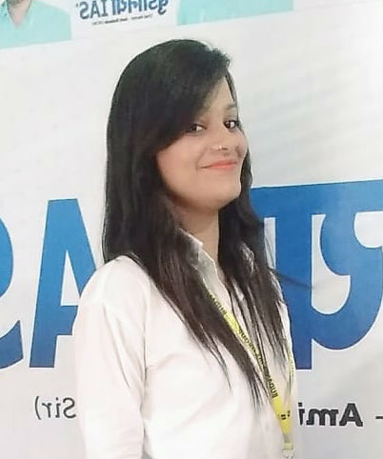

**SWATI MAM**  
(COUNSELLOR BUDANIA IAS )  
Ph.:- 9610246444

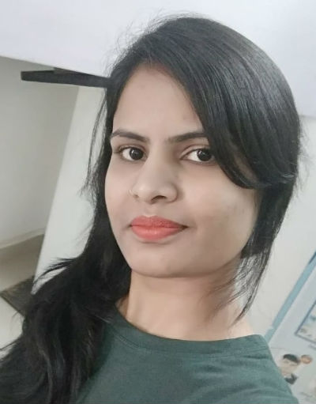

**ANCHAL MAM**  
(ADMINISTRATION BLOCK)  
Ph.:- 9116121935

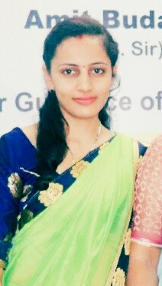

**RITIKA MAM**  
(SENIOR ASSISTANT)  
Ph.:- 7414011336

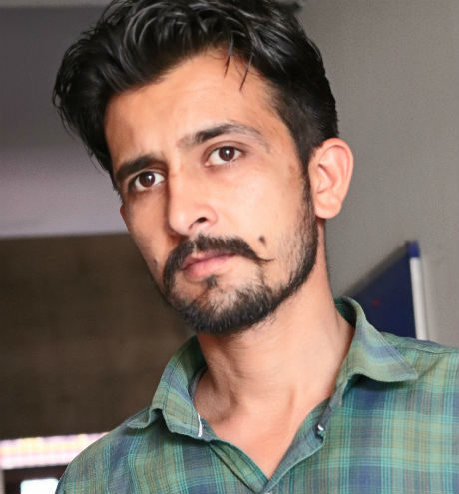

**RAMAWATER SIR**  
(PRINTING AND LOGISTIC HEAD)  
Ph.:- 9587897046

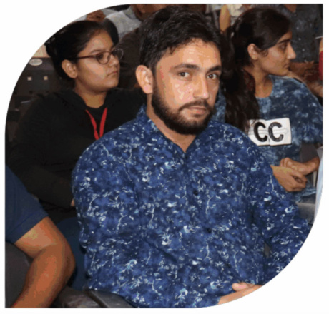

**SANDEEP SIR**  
(IT MANAGER)  
Ph.:- 9587897044

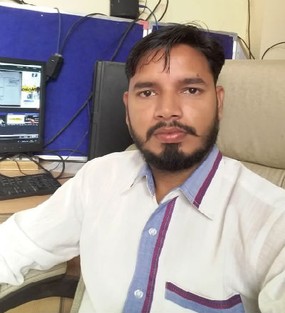

**SURENDRA SIR**  
(IT EXPERT )  
Ph.:- 9587897045